**Requesting Canvas Crosslisting**

HelpDesk web offers forms specific to purposes. To streamline and keep record of staff who choose Canvas crosslisting it is most effective to use the form designed for the process.

1. Go to <https://everettsd.service-now.com/sp>
2. Log in and in the *How can we help?* search field type Canvas crosslisting
3. The option will appear and you should simply select that option.

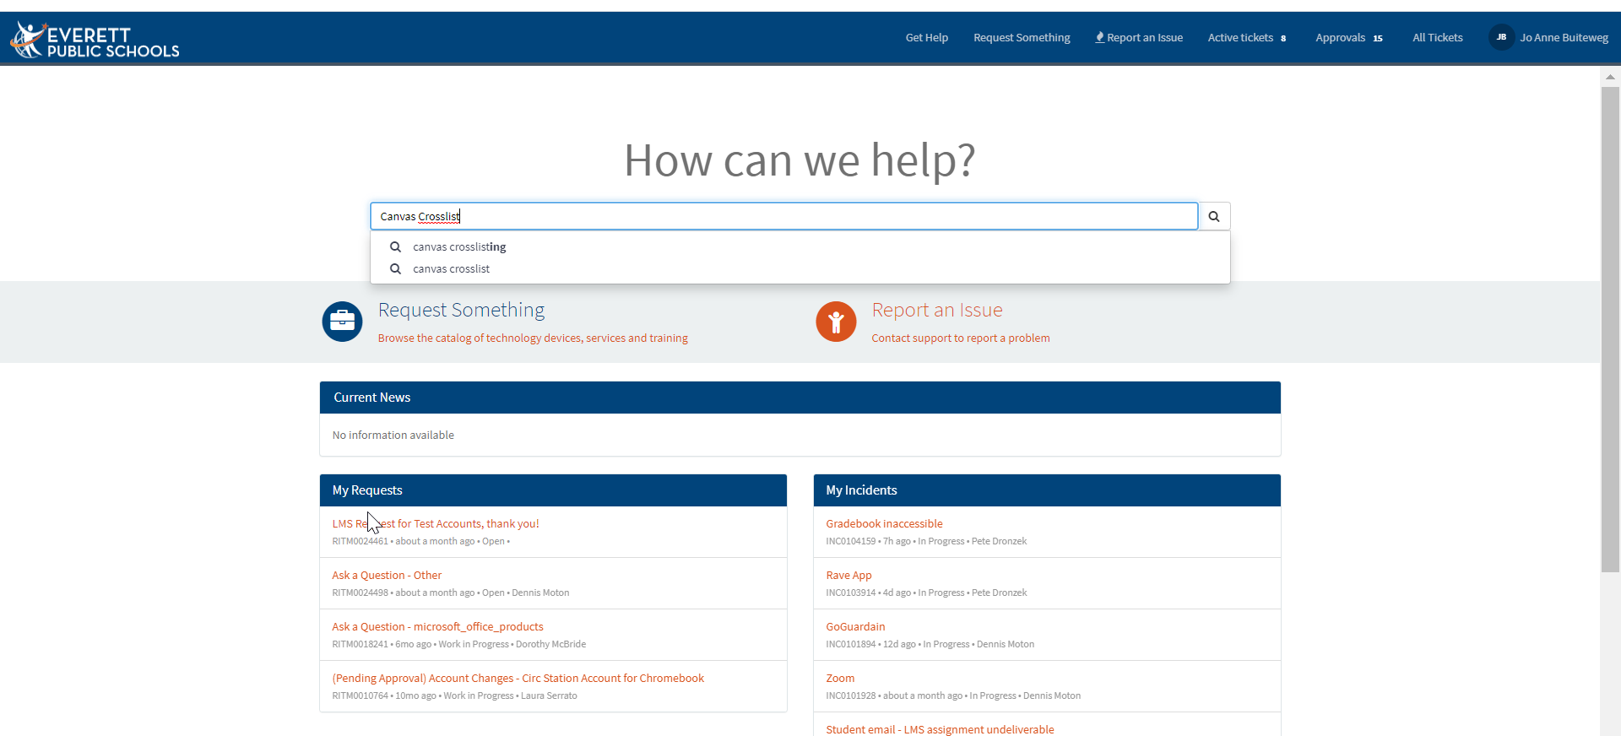

It is important to read through the following. Crosslisting is not appropriate in all cases.

* If curricular content is loaded into the course – it can only be crosslisted with like classes or possibly support courses.
* An existing course must be named to be the “master” course. That is the title that will appear for all students in the other courses crosslisted into the master course. This name cannot be edited.
* Crosslisting cannot be done after student work has been submitted.
* **Special Cases:** If a new course code is required for a course after the start of the semester, it will be crosslisted into the original course and retain that title to keep all historical work active in the newly combined course. This action does require a ticket to assure timing and least disruption in access.